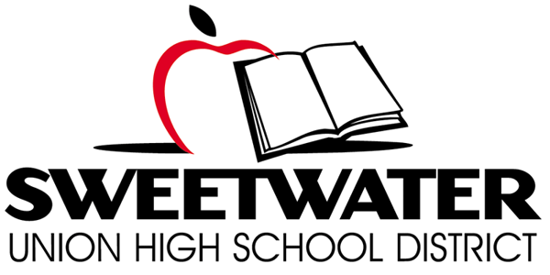

Proposition O Citizens’ Bond Oversight Committee
Wednesday February 22, 2017

TIME: 6:00 p.m. Meeting PLACE: Sweetwater Union High District Offices
1130 District Offices-Room A/B
Chula Vista, CA 91911
Proposition O Ballot Language: School Classroom Safety and Repair Measure. To improve learning/safety at every Sweetwater Union High School District campus by repairing/earthquake retrofitting classrooms/restrooms; installing upgraded fire safety systems, security fencing, safety lighting; upgrading science labs/computer technology; improving handicap accessibility; replacing leaking roofs, heating/air conditioning, outdated plumbing, removing asbestos, mold and lead paint. . .

AGENDA
- Call Meeting to Order @ 6:00 p.m.

- Roll Call & Pledge of Allegiance

- Public Comment

- Approval of Meeting Minutes: 01/18/17 – Un-adopted

- CBOC Vacancies and Application Process

- Bond Project Updates

- Board Items Report

- Status of Performance Audit/Scope of Work and RFQ for FY 16/17

- Six Month Review of Performance Audit Recommendations

- Subcommittee Assignments and Process

- Committee Member Reports

- Meeting Schedule/Format
  - Calendar site locations for future regular CBOC Meetings (site tours)
  - Tour of Plan Room
  - Future Meeting with Board of Trustees

- Staff Announcements/Chair Report

- Adjourn

