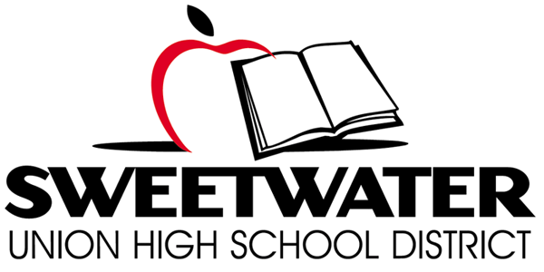

Proposition O Citizens’ Bond Oversight Committee
Wednesday May 17, 2017
TIME: 5:30 p.m. Site Tour PLACE: Southwest Middle School, Library
6:00 Regular Meeting 2710 Iris Avenue
San Diego, CA 92154
Proposition O Ballot Language: School Classroom Safety and Repair Measure. To improve learning/safety at every Sweetwater Union High School District campus by repairing/earthquake retrofitting classrooms/restrooms; installing upgraded fire safety systems, security fencing, safety lighting; upgrading science labs/computer technology; improving handicap accessibility; replacing leaking roofs, heating/air conditioning, outdated plumbing, removing asbestos, mold and lead paint. . .

AGENDA
- Call Meeting to Order @ 5:30 p.m.

- Site Tour

- Roll Call & Pledge of Allegiance

- Public Comment

- Approval of Meeting Minutes: 04/19/17 – Un-adopted

- Progress Report: Implementation of Performance Audit Recommendations

- Progress Report-Maintenance Department Reorganization/Warranty Compliance

- CBOC Vacancies and Application Process-Update

- Bond Project Updates

- Board Items Report/Next Steps Possible November 2018 Bond Measure

- Requests for Information

- Athletic Improvements/Costs to Date-Planned Improvements
- FFE Costs and Inventory National City Middle School Project
- Total Annual Costs of Energy/Savings Solar Projects
- Sweetwater High Various Improvements
- Status of RFP Process for FY 16/17 Performance Audit
- Master Plan Documents

- Committee Member Reports

- Meeting Schedule/Format
  - Calendar site locations for future regular CBOC Meetings (site tours)
  - Tour of Plan Room

- Staff Announcements/Chair Report

- Adjourn

