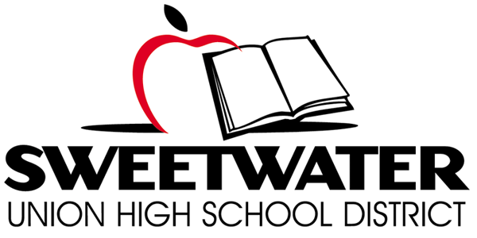

Proposition O Citizens’ Bond Oversight Committee
Wednesday May 17, 2017

TIME: 6:00 p.m. Meeting PLACE: Southwest Middle School-Library
2710 Iris Ave
San Diego, CA 92154

Meeting Minutes

- Call Meeting to Order
Meeting was called to order at 6:05 p.m.

- Site Tour (5:30-6:00 p.m.)

- Roll Call & Pledge of Allegiance
Present: Robert Carriedo, Diane Gerken, Daniel Gutowski, Nick Marinovich, and Rafael Munoz. (Terrance McKearney and Ditas Yamane absent)

District Staff: Karen Janney, Moisés Aguirre, Karl Bradley, Ronald Malone, Roxanna Travers, Colleen Keeran, and Diane Wilderson.

- Public Comment
Kathleen Cheers commented that she has received calls from the eastside schools wondering why they have not been visited by the CBOC since the community members pay bond taxes in those areas. Also, when there is reference to past comments on poor contractors, where was the district personal?

- Approval of Meeting Minutes:
04/19/17 – Approved (with the change of the word viruses to versus implementing). Motion made by Diane Gerken, seconded by Nick Marinovich. (Daniel Gutowski abstained).

- Progress Report: Implementation of Performance Audit Recommendations
Roxanna Travers gave an overview presentation on the Performance Audit Recommendations.

Diane Gerken remarked how she liked the fact that the document was updated in such a timely manner.

Daniel Gutowski commented on the aggressive work to address the issues.

Kathleen Cheers was concerned that the warranty issues, the use of time cards, who would oversee a new bond (third-party or in-house), longevity of consultants, third-party review of purchasing, and the district standards and what they cover.

Nick Marinovich commented on the master plan, is the classroom first priority, and what are the strategic goals of the district?

Nick Marinovich also commented on the staffing plan: one if a new bond is passed and one if a new bond is not passed. Discussion on how to project the plan for the next 10 years.

- Progress Report-Maintenance Department Reorganization/Warranty Compliance
Ronald Malone explained a new program, temporary out of class. This program allows district employees, who have applied for the work pool, to work in open/vacancy positions in the maintenance department.

Ronald Malone gave a presentation on how he is going to track projects/staffing. He reviewed the HVAC staffing.

- CBOC Vacancies and Application Process-Update
Human Resources received two applications for the parent vacancy and 13 applications for the three at-large vacancies. Interviews will be held in early June so candidates can be approved at the June 26 board meeting.

- Bond Project Updates
Nick Marinovich requested that Karl Bradley give an update on the HVAC project. The project is on time to start on Saturday, June 3, 2017.

Nick Marinovich had a concern about the timeline for the BVH athletic field and the EIR. Also, had questions on the progress of the site master plans.

- Board Items Report/Next Steps Possible November 2018 Bond Measure
Karl Bradley gave a presentation on the board items that went to the board for April and May.

Moisés Aguirre gave an update the bond in 2018. The first step is to get a survey consultant to see if the bond would be in 2018 or 2020.

- Requests for Information

- Athletic Improvements/Costs to Date-Planned Improvements
Nick Marinovich requested the total cost of expenditures for all bond projects vs. the cost of athletic improvements during the same period of time. He would like a percentage.

- FFE Costs and Inventory National City Middle School Project
Karl Bradley is still compiling the data. Should be ready for next CBOC meeting.

- Total Annual Costs of Energy/Savings Solar Projects
Robert Carriedo had a question on the Cost Savings vs. Adj Cost Savings. Karl Bradley is going to research and report back at the next CBOC meeting.

- Sweetwater High Various Improvements
Karl Bradley requested clarification on the various projects. Nick Marinovich said his questions have been answered or put on hold to the next meeting.

- Status of RFP Process for FY 16/17 Performance Audit

- Master Plan Documents

- Committee Member Reports

- Meeting Schedule/Format
  - Calendar site locations for future regular CBOC Meetings (site tours) District Office, Rooms A & B
  - Tour of Plan Room

- Staff Announcements/Chair Report

- Adjourn at 8:15

