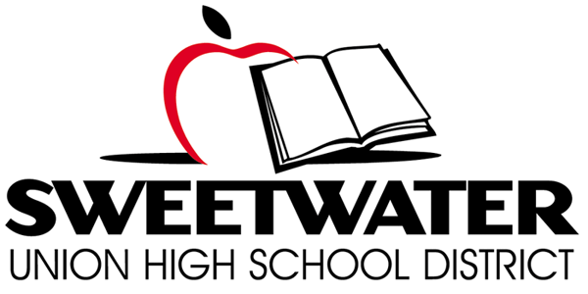

Proposition O Citizens’ Bond Oversight Committee
Wednesday, November 9, 2016

TIME: 5:30 p.m. Site Tour PLACE: Granger Junior High School
6:00 p.m. Meeting 2101 Granger Avenue
National City, CA 91950
Proposition O Ballot Language: School Classroom Safety and Repair Measure. To improve learning/safety at every Sweetwater Union High School District campus by repairing/earthquake retrofitting classrooms/restrooms; installing upgraded fire safety systems, security fencing, safety lighting; upgrading science labs/computer technology; improving handicap accessibility; replacing leaking roofs, heating/air conditioning, outdated plumbing, removing asbestos, mold and lead paint. . .

AGENDA
- Call Meeting to Order @ 5:30 p.m.

- Site Tour 5:30-6:00 p.m.

- Roll Call & Pledge of Allegiance

- Public Comment

- Approval of Meeting Minutes: 10/19/16 – Un-adopted

- Bond Project Updates
- Project Status Reports
- Project Financial Summary
- Program Management Update/Master Plan
- Bond Project Updates

- Board Items Report/Special Board Workshop on Bond Program

- CBOC Role in Future Bond Elections

- Committee Member Reports: Individual members of the CBOC may make announcements or raise issues to be addressed in the future.

- Meeting Schedule/Format
  - Calendar site locations for future regular CBOC Meetings (site tours)
  - Tour of Electronic Records for Bond Program

- Staff Announcements/Chair Report

- Adjourn

