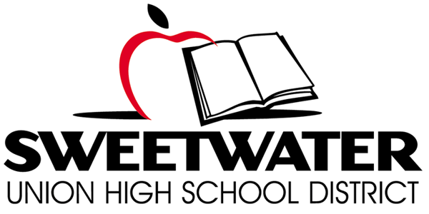

Proposition O Citizens’ Bond Oversight Committee
Wednesday, October 19, 2016

TIME: 5:30 p.m. Site Tour PLACE: Hilltop High School, Room 201
6:00 p.m. Meeting 555 Claire Avenue
Chula Vista, CA 91910
Proposition O Ballot Language: School Classroom Safety and Repair Measure. To improve learning/safety at every Sweetwater Union High School District campus by repairing/earthquake retrofitting classrooms/restrooms; installing upgraded fire safety systems, security fencing, safety lighting; upgrading science labs/computer technology; improving handicap accessibility; replacing leaking roofs, heating/air conditioning, outdated plumbing, removing asbestos, mold and lead paint. . .

AGENDA

- Call Meeting to Order @ 5:30 p.m.

- Site Tour 5:30-6:00 p.m.

- Roll Call & Pledge of Allegiance

- Public Comment

- Approval of Meeting Minutes: 09/21/16 – Un-adopted

- Mutual Settlement Agreement with Whillock Construction

- Paul Woods-District Design Standards Update

- Performance Audit
- District Implementation Plan
- Progress Update
- Scope and Schedule Next Year’s Audit

- Bond Project Updates
- Project Status Reports
- Project Financial Summary
- Program Management Update/Master Plan
- Bond Project Updates
- Athletic Improvements Bond Sale 2
- Enterprise Software System Integration

- Board Items Report

- Status of Warranty Log Implementation

- Annual Report

- CBOC Role in Future Bond Elections/Joint Meeting of CBOC and Board

- Committee Member Reports: Individual members of the CBOC may make announcements or raise issues to be addressed in the future.

- Meeting Schedule/Format
  - Future Training Workshop
  - Calendar site locations for future regular CBOC Meetings (site tours)

- Staff Announcements

- Adjourn

